The British Flyball Association

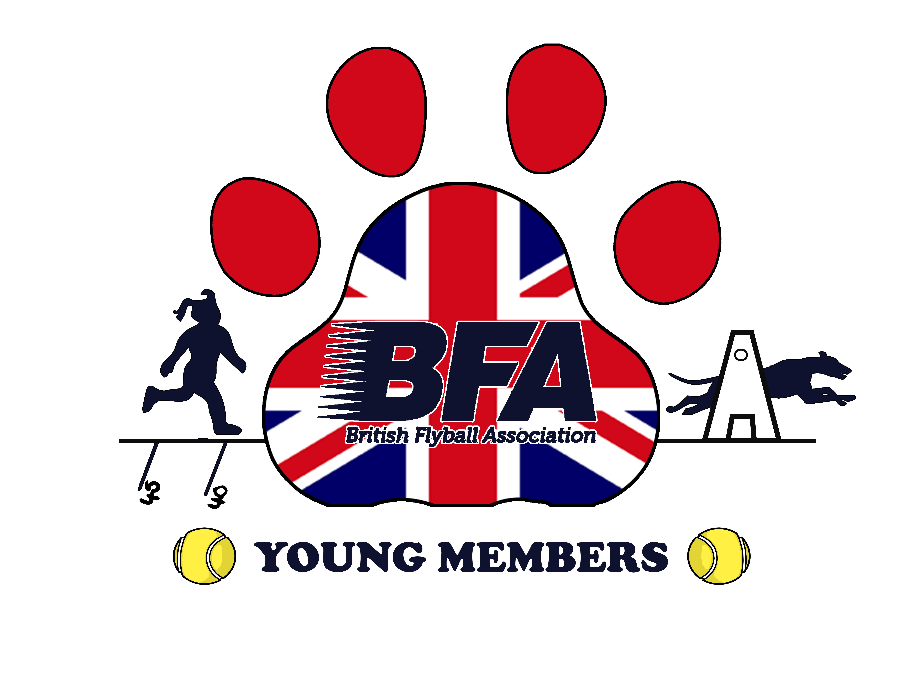
BFA Young Members Award Scheme
EST. 2014 in the 20th Anniversary Year
Introduced in 2005, the BFA Junior Handler Awards have traditionally been an annual competition with two age groups and trophies awarded to third place. The new Young Members Award Scheme will reward all participants with a milestone award scheme for all members aged 4 to 18.
Points are earned in all aspects of Flyball including contribution to team, ring party duties and racing; these young people may become the qualified judges of the future with an all-round in-depth knowledge of the sport.
The awards seek to take the names from previous successful juniors who have achieved 1st place in the Annual Competition along with a precious metal or gemstone, as follows: No two awards will have the same surname.
100 points Silver Aubrey-Wilson Award (Certificate)
200 points Gold Merryman Award (Certificate)
500 points Platinum Frost Award (Certificate)
1000 points Pearl Knott Award (Certificate)
1500 points Jade Mills Award (Certificate)
2000 points Sapphire Jennison Award (Certificate and Glass Award)
2500 points Diamond Barnard Award (Certificate and Glass Award)
3000 points Opal Anderson Award (Certificate and Glass Award)
3500 points Topaz Novasio Award (Certificate and Glass Award)
4000 points Emerald Short Award (Certificate and Glass Award)
5000 points Ruby Barraclough Award (Certificate and Glass Award)
6000 points Amber Reynolds Dobson Award (Certificate and Glass Award)
From 7000 points onwards the Milestone awards will take the surname of the person reaching the required points first adding a precious gem of their choice (if the same person reaches a subsequent award first then a gem and name will be allocated by the Award Secretary).
7000 points Alexandrite Hussain-Barker (Certificate and Glass Award)
8000 points Zircon Charles iii (Certificate and Glass Award)
9000 points Peridot Augustine (Certificate and Glass Award)
10000 points Moonstone Myriad (Certificate and Glass Award)
12000 points Quartz Aquila (Certificate and Glass Award)
14000 points Lapis Lazuli Georgia (Certificate and Glass Award)

Points are awarded as follows.
100 points (equal to the 1st milestone certificate) when a BFA member aged between 4 and 18 has been an active member of a registered BFA Flyball Team or Teams for a year, the active team member points can only be awarded once (this award is to allow buy-in to the scheme by the current young members, parents/guardians, and team captains, allowing the first certificate to be awarded early in the scheme)
20 points - when the member is a Handler of a dog in a BFA team at a sanctioned open, multibreed, singles or pairs tournament or foundation event (within a sanctioned tournament). (These points are earned per ½ division or a minimum of 2 races in staggered format).
20 points - when a member is the Boxloader for a BFA team at a sanctioned open, multibreed, singles or pairs tournament or foundation event (within a sanctioned tournament). (These points are earned per ½ division or a minimum of 2 races in staggered format).
15 points – when a member performs ring party duty; either Line judge, scribe or box judge, at a sanctioned open, multibreed, singles or pairs tournament or foundation event (within a sanctioned tournament). (These points are earned per ½ division or a minimum of 7 races in staggered format).
15 points – when a member performs Team Duties (ball collecting, line, jumps, stride poles, holding dogs, positioning jump boards/poles, recording dog times) for their own or any other BFA registered team at a sanctioned open, multibreed, singles or pairs tournament or foundation event, (These points are earned per division ½ division or a minimum of 2 races in staggered).
All BFA Members under the age of 18 remain the responsibility of their parent or guardian whose responsibility it is to ensure the safeguarding of the young person whilst carrying out the roles within a BFA sanctioned ring.
All young members performing ring party duties or divisional judging must be mentored whilst learning the roles undertaken, where possible young members should attend a ring party training seminar in their region. Team Captains must assure themselves that the young member is competent to undertake ring party roles or provide appropriate supervision.
Young Members Registration Form to record the young members name, BFA number, age and date of registration, can be found on the BFA website following this link.
https://www.flyball.org.uk/sites/default/files/downloads/young%20members%20registration%20form_0.pdf
Young Members Milestone awards can be claimed by using the Points Record Form to record the young members points for each tournament attended, can be found on the BFA website following this link.
https://www.flyball.org.uk/sites/default/files/downloads/young%20members%20points%20form_0.pdf
Young Members Facebook Page can be found using the following link.
https://www.facebook.com/groups/480224079403223/

