The British Flyball Association
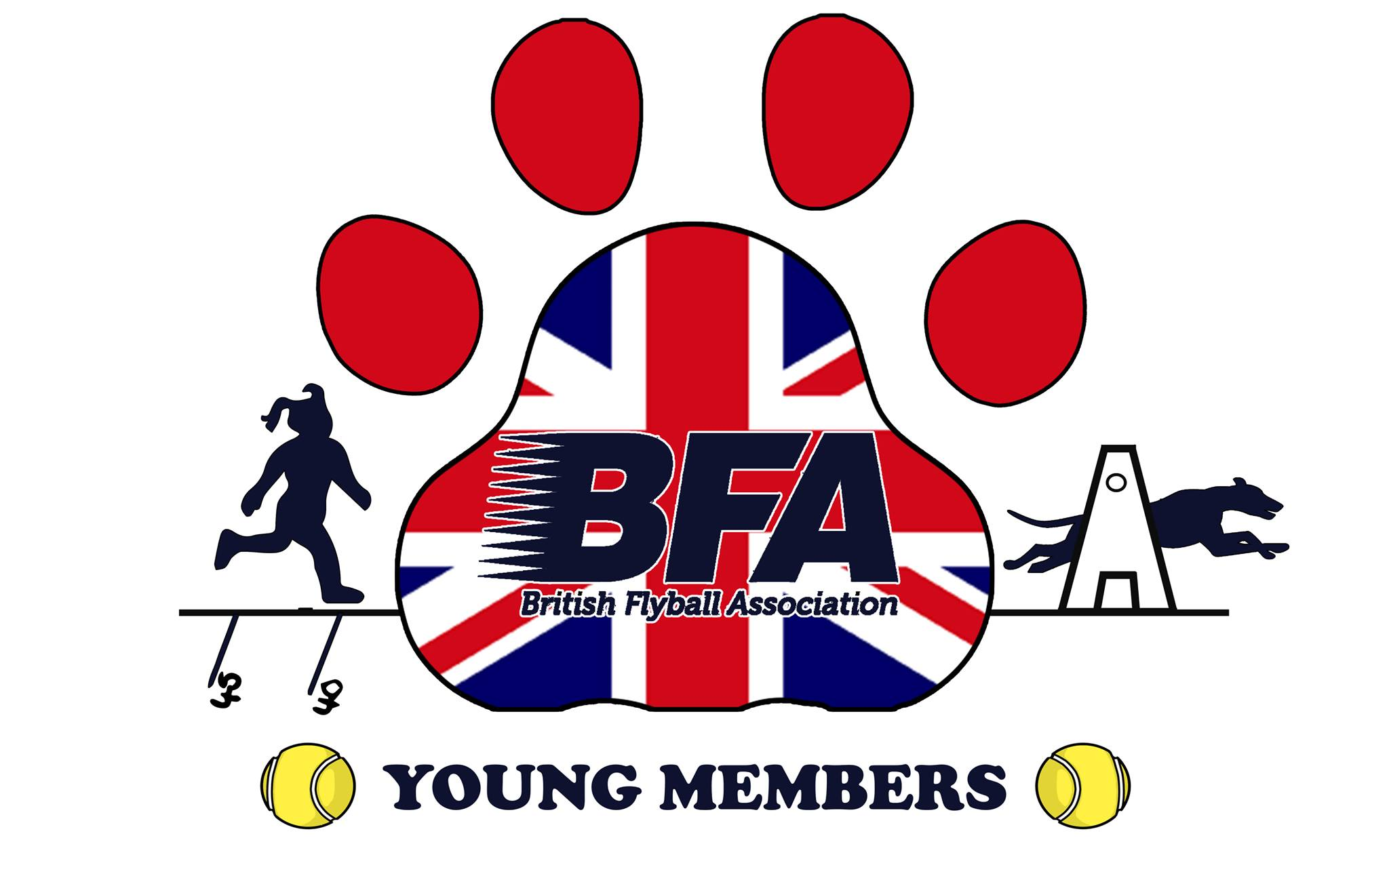

BFA Young Members Award Scheme
Please complete one form for each sanctioned tournament or foundation event attended. When enough points are gained for an award, send a copy/copies of this form to the BFA Awards Co-ordinator.

Name: | BFA Number:
BFA Team: | BFA Team Number:
Sanctioned Tournament: | Date/s of Tournament:
Name of Tournament Head Judge: | What type of Tournament: Open, Multibreed, Foundation
O

Handling of a dog. (20 points earned per ½ division or a minimum of 2 races in staggered format)

How Many ½ Divisions Did You Handle a Dog For?

Box Loading. (20 points earned per ½ division or a minimum of 2 races in staggered format)

How Many ½ Divisions Did You Box Load For?

Ring Party Duty. (15 points earned per ½ division or a minimum of 7 races in staggered format)

How Many ½ Divisions Did You Compete Ring Party Duties?

Ball Collecting. (10 points earned per ½ division or a minimum of 2 races in staggered format)

How Many ½ Divisions Did You Ball Collect For a Team?

Total Points Claimed:

This form is to be signed as correct by the parent or guardian.
Parent or Guardian.
Signed: | Date:
Name:

Return form to the BFA Awards Co-ordinator at the following postal address or email.
Young Members Awards Co-Ordinator, 20 The Coppice, Sutton-in-Craven, Keighley, West Yorkshire. BD20 8BT

Email: jeff_pdac@hotmail.com

