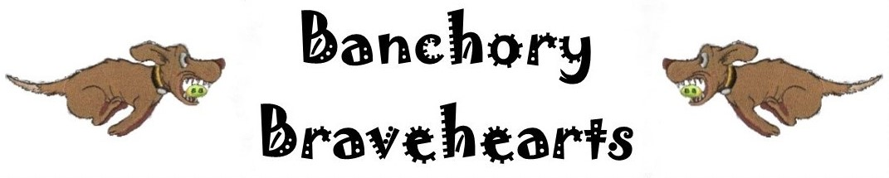

Invite you to a BFA



LIMITED OPEN SANCTIONED TOURNAMENT (54 TEAMS)
On Saturday 4th & Sunday 5th May 2019
&

Starters Competition

Closing date for all entries 5th April 2019

To be held at: Milton of Crathes, Banchory, Aberdeenshire, AB31 5QH (nearest postcode)

Racing will be Round Robin Block Format on Grass

PLEASE NOTE: No entries can be accepted without payment

For further information contact Lynne Laing
24 Bellwood Drive, Aboyne, Aberdeenshire, AB34 5QG
(07977 184 488) lynnelaing124@gmail.com

Banchory Bravehearts

Entry Form

LIMITED OPEN SANCTIONED TOURNAMENT
at Milton of Crathes, Banchory, AB31 5QH
On Saturday 4th & Sunday 5th May 2019
Closing date for entries 5th April 2019

Team Name/s | BFA Team Number
1
2
3
4
5

Declared times must be submitted in writing (or email) by 19th April 2019 and must be at least 0.5 faster or slower than seed time (see BFA Rule 4.3). Team break-out time is half a second faster than declared time. All times, seed or declared, except Div 1, are subject to the division break out rule. BFA rule 11.

STARTERS TOURNAMENT
Team Name/s | BFA Team Number
1
2
3
4

Team Captain
Name: | Address:
Captain BFA Number: | Address:
Telephone Number: | Address:
E-Mail address: | Address:

Judges
Judges availability (please tick appropriate box and supply name). | Provisional judge (requires supervision) | Qualified Judge

Open Team Entry @ £40 per team |  | £
Starters Team Entry @ £25 per team |  | £
Camping @ £8 per unit per night. | Number of units Friday | £
Camping @ £8 per unit per night. | Number of units Saturday | £
TOTAL PAYMENT |  | £

All Entries (Cheques payable to Gordon McWilliam Account No: 01065265 Sort code: 80-45-86)

Complete and return to: Lynne Laing, 24 BELLWOOD DRIVE, ABOYNE, ABERDEENSHIRE, AB34 5QG email: lynnelaing124@gmail.com. Final running orders will be sent out approximately 1 week before the tournament.

NO ENTRIES WILL BE ACCEPTED WITHOUT PAYMENT

Show Rules and Regulations

NO DOGS TO GO INTO THE RIVER DEE WHICH IS ADJACENT TO VENUE

1. The tournament organiser(s) reserve the right to refuse entries and admission to any person not in good standing with the B.F.A.
2. B.F.A. rules and policies will apply throughout the sanctioned tournament.
3. No person shall carry out punitive or harsh handling of a dog at the tournament.
4. It is the Team Captains responsibility to ensure the Team is available for its class and running order.
5. The organiser(s) reserve the right to make any alterations they deem necessary in the event of unforeseen circumstances.
6. Bitches in season are not allowed near the show area. Mating of dogs is not allowed.
7. A dog must be withdrawn from competition if it is:
a. Suffering from any infectious or contagious disease
b. A danger to safety of any person or animal
c. Likely to cause suffering to the dog if it continues to compete
8. All dogs enter into the tournament at their own risk and whilst every care will be taken, the organiser(s) cannot accept responsibility for damage, injury or loss however caused to dogs, persons or property whilst at the event.
9. All owners/handlers must clean up after their dogs. Anyone failing to do so will be asked to leave the venue.
10. No alcohol is to be consumed within or around the ring.
11. NO BARBEQUES TO BE USED DIRECTLY ON THE GRASS
12. Starters will be run based on current BFA rules. Jump heights and assistance at the box are left to the discretion of individual teams, based on the ability of their team. Any Non BFA Members competing in Starters are the responsibility of the Primary Team Captain.
13. If circumstances make it necessary that the tournament is cancelled, the organisers reserve the right to defray expenses incurred by deducting such expenses from entry fees received.

Directions

Milton of Crathes, Banchory, Aberdeenshire, AB31 5QH

The venue is on the A93 road that runs through Banchory, it is next to the Milton Restaurant and across the road from the entrance to Crathes Castle.

From the south

DO NOT TAKE THE B974 FETTERCAIRN or B966 EDZELL roads if towing as they are not suitable for large vehicles.

Dundee A90 north and through Stonehaven to Slug Road A957

Take 2nd turn off to Stonehaven from A90 follow signs below

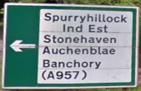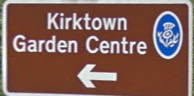

Follow Broomhill Road

Turn left onto Auchenblae Road

Turn right onto Farrochie Road

At mini roundablout turn left onto A957 Slug Road

At junction with A93 turn left onto A93

Arrive Milton of Crathes. Turn left

Entrance to event field is on the right beside Deeside Railway.

