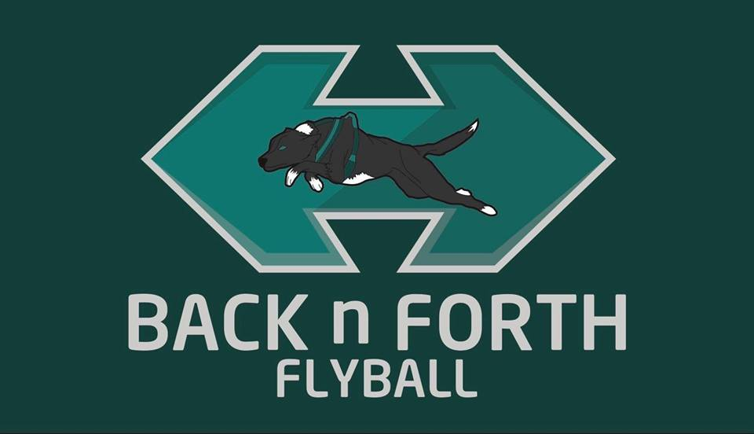

Invite you to a BFA

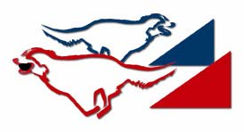

LIMITED OPEN SANCTIONED TOURNAMENT (24 TEAMS)
On Saturday 23rd June 2018
&

Starters Competition

Closing date for all entries 29th May 2018

To be held at: Lethangie Campsite, Kinross, Perth & Kinross, KY13 9EY

Racing will be Round Robin Block Format on Grass

For further information contact:
Paula Holmes
75 Harbour Place, Dalgety Bay, Dunfermline, Fife, KY11 9GD
(07875 709 865) weebroon24@yahoo.co.uk

Back n Forth
Entry Form

LIMITED OPEN SANCTIONED TOURNAMENT
at Lethangie Campsite, Kinross, KY13 9EY
On Saturday 23rd June 2018
Closing date for entries 29th May 2018

Team Name/s | BFA Team Number
1
2
3
4
5

Declared times must be submitted in writing (or email) by 8th June 2018 and must be at least 0.5 faster or slower than seed time (see BFA Rule 4.4). Team break-out time is half a second faster than declared time. All times, seed or declared, except Div 1, are subject to the division break out rule. BFA rule 5.17(I).

STARTERS TOURNAMENT
Team Name/s | BFA Team Number
1
2
3
4

Team Captain
Name: | Address:
Captain BFA Number: | Address:
Telephone Number: | Address:
E-Mail address: | Address:

Judges
Judges availability (please tick appropriate box and supply name). | Provisional judge (requires supervision) | Qualified Judge

Open Team Entry @ £40 per team |  | £
Starters Team Entry @ £25 per team |  | £
TOTAL PAYMENT |  | £

All Entries (Cheques payable to Paula Holmes or bank transfer to S/C 80-31-50 ACC 10568061)

Please complete and return to: Paula Holmes, 75 Harbour Place, Dalgety Bay, Fife KY11 9GD or email weebroon24@yahoo.co.uk

Final running orders will be sent out approximately 1 week before the tournament.

Show Rules and Regulations

1. The tournament organiser(s) reserve the right to refuse entries and admission to any person not in good standing with the B.F.A.
2. B.F.A. rules and policies will apply throughout the sanctioned tournament.
3. No person shall carry out punitive or harsh handling of a dog at the tournament.
4. It is the Team Captains responsibility to ensure the Team is available for its class and running order.
5. The organiser(s) reserve the right to make any alterations they deem necessary in the event of unforeseen circumstances.
6. Bitches in season are not allowed near the show area. Mating of dogs is not allowed.
7. A dog must be withdrawn from competition if it is:
a. Suffering from any infectious or contagious disease
b. A danger to safety of any person or animal
c. Likely to cause suffering to the dog if it continues to compete
8. All dogs enter into the tournament at their own risk and whilst every care will be taken, the organiser(s) cannot accept responsibility for damage, injury or loss however caused to dogs, persons or property whilst at the event.
9. All owners/handlers must clean up after their dogs. Anyone failing to do so will be asked to leave the venue.
10. No alcohol is to be consumed within or around the ring.
11. NO BARBEQUES TO BE USED DIRECTLY ON THE GRASS
12. Starters will be run based on current BFA rules. Jump heights and assistance at the box are left to the discretion of individual teams, based on the ability of their team. Any Non BFA Members competing in Starters are the responsibility of the Primary Team Captain.
13. If circumstances make it necessary that the tournament is cancelled, the organisers reserve the right to defray expenses incurred by deducting such expenses from entry fees received.

Directions

Lethangie Campsite, Kinross, KY13 9EY

The venue is on the A922 road that runs through Kinross, it is next to the grounds of Kinross High School/Loch Leven Community Campus.

From the M90 and through Kinross on the A922

- Take junction 6 from the M90
- From the north, take exit 1 at roundabout
- From the south, take exit 3 at roundabout
- Turn left onto Springfield Road
- Follow Springfield Road to T junction
- Turn left
- Follow the A922 through Kinross
- Pass Loch Leven Community Campus on the right
- Continue past the playing fields
- Turn right at the small cottage with green railings
- Entrance to the venue is approx 100m down farm road

