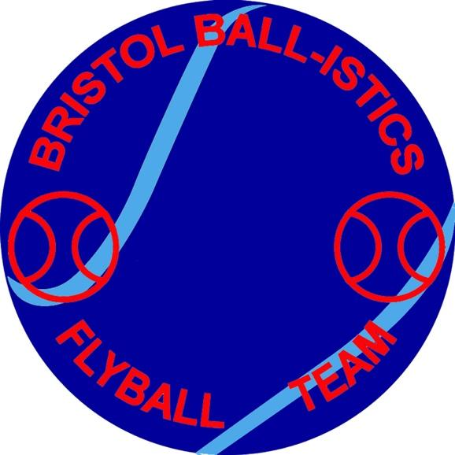

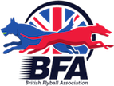

Inviting you to our Show

British Flyball Association

Limited Open Competition

West Woodlands Showground

Bunns Lane, Frome

Somerset, BA11 5ES

What3words ///direction.veiws.evaporate

On 21st & 22nd June 2025

Limited Open to 48 Teams Over 2 Days

Camping Available Friday & Saturday Night

£12 per unit per night.

Entries via Google form

<https://forms.gle/XqD4VA61R3AiRfDd7>

You will have a copy of your entry emailed to you.

All Enquires please email to   
[Bristolballisticsclub@gmail.com](mailto:Bristolballisticsclub@gmail.com)

Show Rules and Regulations

(1) The Tournament Organiser(s) reserve the right to refuse entries and admission to

the event of any persons not in good standing within the BFA.

(2) No person shall carry out punitive or harsh handling of a dog at the event.

(3) Bitches in season are not allowed near the tournament area. Mating of dogs is not allowed.

(4) A dog must be withdrawn from competition if it is:

(A) Suffering from infectious or contagious diseases.

(B) A danger to the safety of any person or animal.

(C) Likely to cause suffering to the dog if it continues to compete.

(5) It is the Team Captain’s responsibility to ensure the Team is available for their

Division and running order.

(6) The Organiser(s) reserve the right to make any alterations they deem necessary in

the event of unforeseen circumstances.

(7) If circumstances make it necessary to cancel the Tournament, the Organiser(s)

reserve the right to defray expenses incurred by deducting such expenses from the

entry fees received.

(8) All dogs enter the event at their own risk and whilst every care will be taken, the

Tournament Organiser(s) cannot accept responsibility for damage, injury, or loss

however caused to dogs, persons or property whilst at the event.

(9) All owners/handlers must clear up after their dogs. Anyone failing to do so will be

asked to leave the venue.

(10) Current BFA Rules and Policies will apply throughout the Sanctioned Tournament.

(11) No person shall impugn the decision of the head judge or judges.

Current BFA Rules and Policies will Apply throughout the Sanctioned Tournament.