Barkshire Bandits
Flyball Team

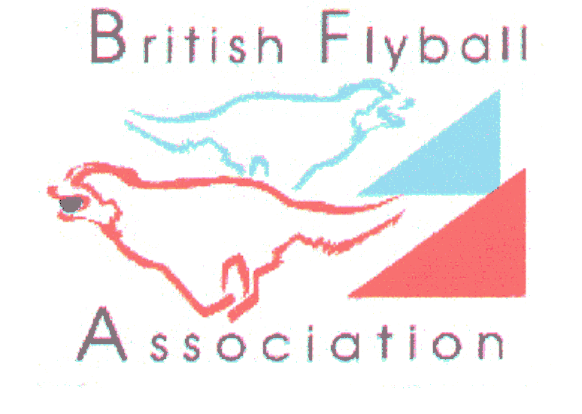
Present

LIMITED OPEN

SANCTIONED COMPETITION
Sponsored By 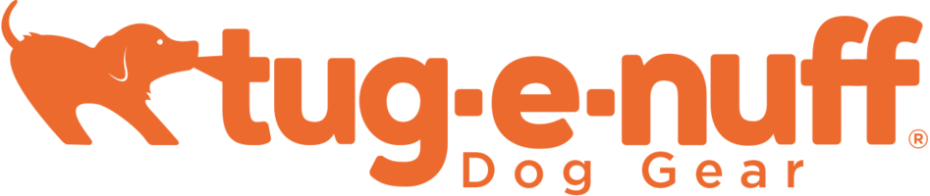

DIANA BRIMBLECOMBE ANIMAL RESCUE CENTRE

Nelsons Lane, Hurst, Nr Wokingham, Berkshire.

RG10 0RR

on
SATURDAY/ SUNDAY
8th & 9th September 2018
Closing date 8th August 2018

FEATURING: LIMITED 96 TEAM COMPETITION

FOR FURTHER INFORMATION CONTACT:
PENNY CHARLTON TEL:01628 829623/07708 458742

Entries accepted online EMAIL: penny.barkshirebandits@yahoo.co.uk

Barkshire BanditsFlyball Team

Limited Open Sanctioned Competition

Diana Brimblecombe Rescue Centre
8/9th September 2018 (96 teams)
Closing date for entries: 8th August 2018
Declared times must be submitted in writing (or email) at least 14 days before the
Tournament and must be at least a half second slower or faster than seed time.

Team Name | BFA No

Team Captain:
Address

Telephone:
Email:

No Of Teams Entered ______@ £40 per Team = £_____________

Camping @ £8 per unit per night = £ _____________

TOTAL ENCLOSED = £_____________

If time, a starters competition may be run, if interested please tick here...........................

JUDGING: Please name anyone from your team, with their qualifications (if any), who you think capable and would be happy to judge one of the divisions
Qualified........
Provisional....
Measurer……
Please make cheques payable to Barkshire Bandits Flyball Team
Returns and Enquiries to:
Penny Charlton

2 Heywood Farm Cottages
Snowball Hill
Maidenhead
Berkshire. SL6 3LU TELEPHONE: 01628 829623

Email entries to: penny.barkshirebandits@yahoo.co.uk

Show rules and regulations

- The event organisers reserve the right to refuse entries and admission to the event of any persons not in good standing within the BFA.

- It is the team captain’s responsibility to ensure the team is available for their divisions and running order.

- No person shall impugn the decision of the head judge or judges.

- The organisers reserve the right to make any alterations they deem necessary in the event of unforeseen circumstances.

- All dogs are entered in this event at their owners risk and, whilst every care will be taken, the event organisers cannot accept responsibility for damage, injury or loss however caused to dogs, persons or property whilst at the event.

- If circumstances make it necessary to cancel the Tournament, the Organiser(s) reserve the right to defray expenses incurred by deducting such expenses from the entry fees received.

- All owners/handlers must clear up after their dogs. Anyone failing to do so will be asked to leave the venue.

- We will try to accommodate teams who request specific days however this cannot be guaranteed. The running order cannot be considered until two weeks prior to the event at the earliest due to the seed list update and therefore it is impossible to guarantee any request until that time whether successful or not. Refunds will not be issued if we are unable to accommodate your request and you withdraw beyond the competition closing date.

Current BFA Rules and Policies will apply throughout the Sanctioned Tournament



