
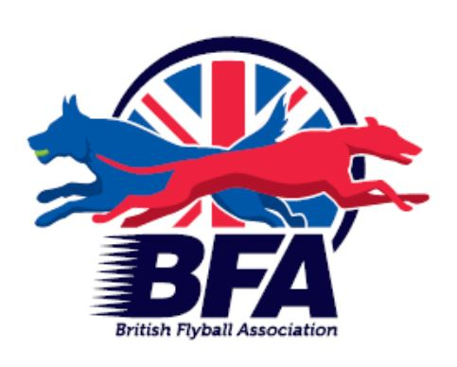
British Flyball Association
Sanctioned Limited Open
Tournament (96 Teams)
At
Epworth Show Field
Wroot Road
Epworth
Doncaster
DN9 1EA
On
Saturday 12th April 2025
and Sunday 13th April 2025
(Closing Date12th March 2025)
Over two days.

Please contact Martyn or Joanna Bonner
01909808904 or 07557733878
nottssupadogs@hotmail.co.uk

DIRECTIONS
What Three words:
Sporting.paving.president

Directions to Epworth Showground
For those using SAT NAV the address is;
Wroot Rd
Epworth,
Doncaster,
South Yorkshire
DN9 1LA,

From the north

Leave the M180 Junction 2 and follow the A161 into Epworth. At the traffic lights at the side of the White Bear Inn turn right onto High Street.

From the south

Approach Epworth on the A161 until you reach the traffic lights in front of the White Bear Inn. Turn Left onto High Street.

From High Street

Follow High Street until left hand turn onto Battle Green (opposite phone box and Travis Perkins entrance) Just after the childrens playground on the right, the road bends to the left onto Fieldside (DO NOT continue along Battle Green) Shortly after, the road continues around a right hand bend onto Carrside. Follow this road for approx. a mile to the venue.

(Contact Jo or Martyn on 07557733878)

Further information, queries and entries to:
Martyn Bonner
50 Westmorland Drive
Costhorpe
Worksop
Nottinghamshire
S81 9JT
Tel: 01909808904 or 07557733878
Email: nottssupadogs@hotmail.co.uk

Show Rules and Regulations
(1) The Event Organiser(s) reserve the right to refuse entries and admission to the event of any persons not in good standing within the BFA.
(2) No person shall carry out punitive or harsh handling of a dog at the event.
(3) Bitches in season are not allowed near the show area. Mating of dogs is not allowed.
(4) A dog must be withdrawn from competition if it is:
(a) Suffering from infectious or contagious diseases.
(b) A danger to the safety of any person or animal.
(c) Likely to cause suffering to the dog if it continues to compete.
(5) It is the Teams Captain’s responsibility to ensure the team is available for their Races.
(6) The organiser(s) reserve the right to make any alterations they deem necessary in the event of unforeseen circumstances.
(7) All dogs enter the event at their own risk and whilst every care will be taken, the Event Organiser(s) cannot accept responsibility for damage, injury, or loss however caused to dogs, persons or property whilst at the event.
(8) All owners/handlers must clear up after their dogs. Anyone failing to do so will be asked to leave the venue.
(9) BFA Rules and Policies will apply throughout the Sanctioned Tournament
(10) If circumstances make it necessary to cancel the tournament the organisers reserve the right to defray expenses incurred by deducting such expenses from the entry fees received

Please be aware of the following rules that apply to this venue;

(11) All competitors MUST obey any “out of bounds” or restricted areas that are in place on the show field.
(12) All competitors and visitors are responsible for their dogs and must make every effort to ensure they do not cause noise nuisance when not racing (or waiting to race to the homes surrounding the show field.

Saturday 12th and Sunday 13th April 2025
Entry Fee £50 per Open Team
Declared times must be submitted in writing (or email) at least 14 days before the
Tournament and must be at least one half second faster or half a second slower than seed time. (BFA rule A1:4.3)
Team break-out time is 0.25 second faster than declared time (A3:11)
All times, seed or declared, except Div 1, are subject to the division break-out rule.
TEAM NAME | Open or Foundation  (Foundation subject to open entry level) | If open - TRN
1.
2.
3.
4.
5.
6.

Team Captain’s name
Telephone
Address
Email
Camping @ £12.00 per night
 | FRIDAY | SATURDAY
No. of Caravans
No. of Tents

Number of teams entered ..............at £50 per OPEN team, £8.00 per FOUNDATION dog entered max £32.00 per team
Camping fees £………… (£12.00 per night per unit)
Bank transfer: Sort code: 20-55-62 Acc No: 33487237 Use Team name as reference

Available Head Judge/Judges/ MO/Regional Reps? Name/s……………………………………………………………………………………

