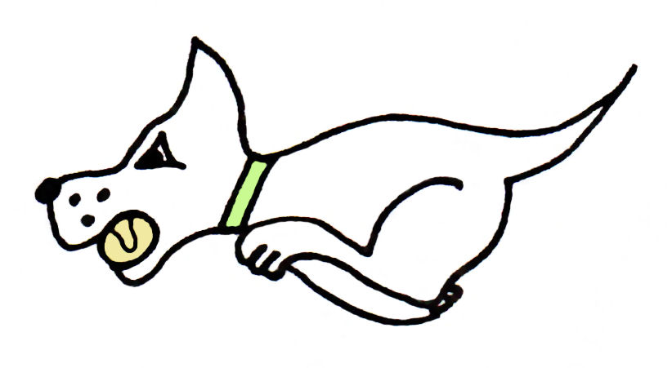Kennet Flyball Club
present a


Kennet 10th Anniversary
SANCTIONED LIMITED OPEN TOURNAMENT (78 TEAMS) SATURDAY & SUNDAY

At
Padworth Village Hall
Padworth Lane, Padworth, Reading, Berks RG7 4HY
(just off A4)

1 & 2 September 2018 Open

(Closing date for entries: 3 August)

Information
Electronic entries accepted

Hot Food and drinks will be available on site.

Camping Facilities £8 per unit per night
excellent facilities with indoor showers and toilets

We will be having a party to celebrate our 10th Anniversary with a disco on the Saturday evening, everyone welcome, bring your own drinks.



Kennet Flyball Club
Requests for specific days
As always we will try to accommodate teams who request specific days however this cannot be guaranteed. The running order cannot be considered until two weeks prior to the
event at the earliest due to the seed list update and therefore it is impossible to guarantee any request until that time whether successful or not. Refunds will not be issued if we are unable to accommodate your request and you withdraw beyond the competition closing date.
Tournament Rules and Regulations
(1) The Tournament Organiser(s) reserve the right to refuse entries and admission to
the event of any persons not in good standing within the BFA.

(2) No person shall carry out punitive or harsh handling of a dog at the event.

(3) Bitches in season are not allowed near the tournament area. Mating of dogs is not
allowed. Any bitch due to whelp within seven days of the competitions is not
permitted at the Tournament. No bitch can compete whilst in pup and for at least
eight weeks after giving birth.

(4) A dog must be withdrawn from competition if it is:
(A) Suffering from infectious or contagious diseases.
(B) A danger to the safety of any person or animal.
(C) Likely to cause suffering to the dog if it continues to compete.

(5) It is the Team Captain’s responsibility to ensure the Team is available for their
Division and running order.

(6) The Organiser(s) reserve the right to make any alterations they deem necessary in
the event of unforeseen circumstances.

(7) If circumstances make it necessary to cancel the Tournament, the Organiser(s)
reserve the right to defray expenses incurred by deducting such expenses from the
entry fees received.

(8) All dogs enter the event at their own risk and whilst every care will be taken, the
Tournament Organiser(s) cannot accept responsibility for damage, injury, or loss
however caused to dogs, persons or property whilst at the event.

(9) All owners/handlers must clear up after their dogs. Anyone failing to do so will be
asked to leave the venue.

(10) Current BFA Rules and Policies will apply throughout the Sanctioned Tournament.

(11) No person shall impugn the decision of the head judge or judges.

(12) No ground level BBQs are allowed

(13) Dogs who are entered for Starters competition shall not be eligible to enter Open at this Tournament and vise versa

(14) The ‘two minute rule’ 5.15(a) will apply throughout the tournament.

Kennet Flyball Club
SANCTIONED LIMITED OPEN TOURNAMENT (78 TEAMS) 1 & 2 September 2018

Declared times must be submitted in writing (or email) at Least 14 days before the tournament and must be at least one second slower than seed time. (BFA rule 4.5)
Team break out time is half a second faster than declared time (BFA rule 5.17(I))
Declared times faster than seed time are not subject to the team break out rule.
All times, seed or declared, except Div 1, are subject to the division break out rule.

Team Name: | BFA Number
1)
2)
3)
4)
5)

Team Captain:

Address:

Post Code:

Telephone:

Email:

If you are able to provide a judge or measurer for our show, please indicate this below.

Provisional Judge

Qualified Judge

Measurer (PorQ)

Kennet Flyball Club
FINANCIAL SUMMARY Sep 18

 | Numbers | Cost | Sub-totals
Club name:

Number of open teams entered |  | @ £40.00 each
Number of camping units @ £8.00 per night | Fri Sat
 |  | GRAND TOTAL

Electronic entries accepted.
Please email to : kennetflyball@yahoo.co.uk

Bank details for payment:
Pay to Kennet Flyball Club
Barclays bank Sort code 20-05-00 A/C number 63520234
Ref : please enter your club name

Should we be oversubscribed entries will be refunded.

Postal entries also accepted:

Please make all cheques payable to Kennet Flyball Club

Please advise email for tournament information and running orders.

All entries received by email will be acknowledged. If you haven’t had an email reply from us then we have not received your email so please check with us.

All entries should be posted to:

Becky Black,
21 Mount Pleasant,
Tadley,
Hampshire
RG26 4JR

Enquiries: Tel: Garry 07789 692326

Directions RG7 4HY
From the M4
Leave the M4 at Junction 12 and take the A4 towards Theale/Thatcham/Newbury
After 4 miles, as the dual carriageway ends, just past the Total Garage turn left, opposite the Anchor Van Centre. The hall is on the left after ¼ mile.

From the M3
Leave the M3 at Junction 6. To navigate the Basingstoke roundabouts follow signs for Hospital A&E & to the A340 Aldermaston/Tadley. Go past the hospital and continue through Tadley, at the top of Tadley the AWE will be on your right, stay on the A340 to Aldermaston & Pangbourne. At the A340/A4 roundabout turn right. After 50 yds turn right again opposite the Anchor Van Centre. The hall is on the left after ¼ mile

