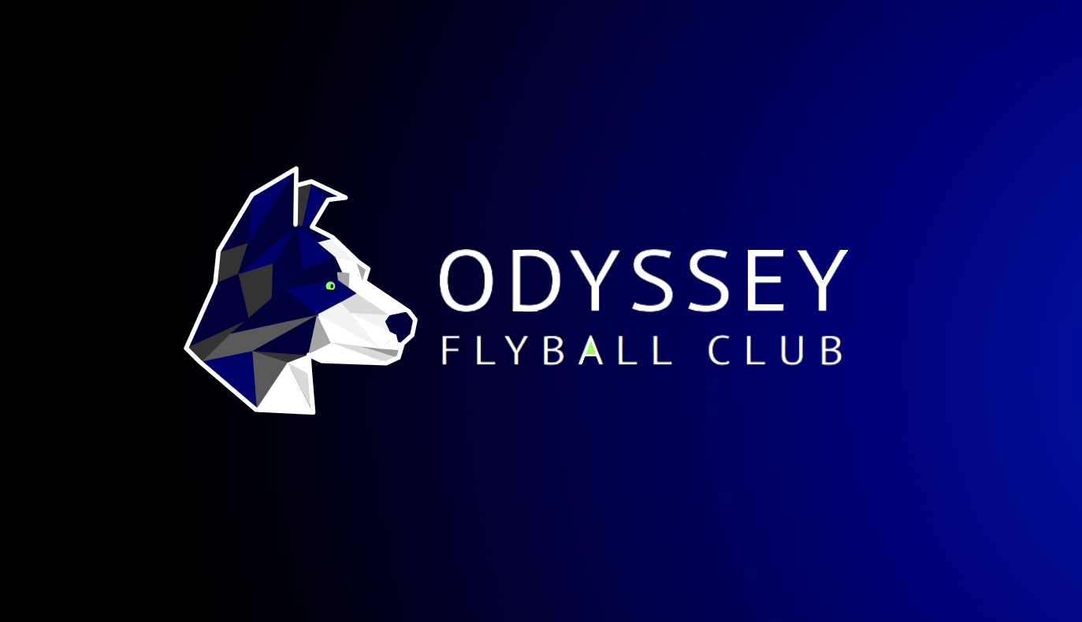

**PRESENTS**  
**A SANCTIONED LIMITED OPEN TOURNAMENT**

**(48 TEAMS)**

**AT**

**Lydiard Park,**

**Lydiard Tregoze,**

**Swindon**

**SN5 3PA**

**ON**

Saturday 16th & Sunday 17th September 2023

**Online Entry**

Please click on the link to enter using our online form:

<https://forms.gle/KFcVKyRJgDuBb5FH8>

(**Closing date for entries 18th August 2023)**

For further information contact:  
Mark Pitts  
Telephone: 07814 505153

E-mail: [odysseyflyball@gmail.com](mailto:odysseyflyball@gmail.com)

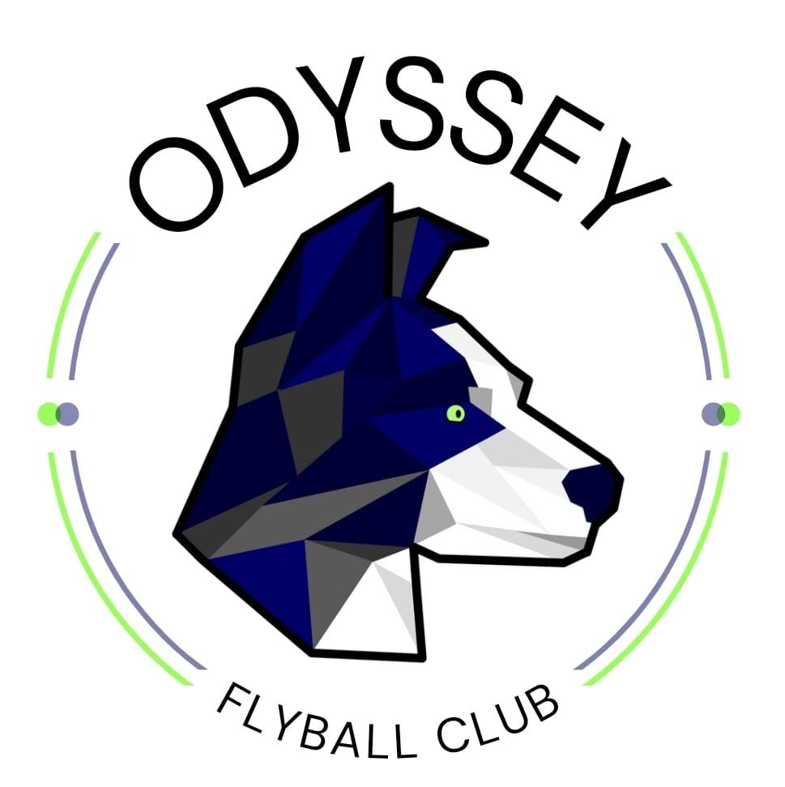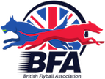

**Location**(What3words will be published with the running order)

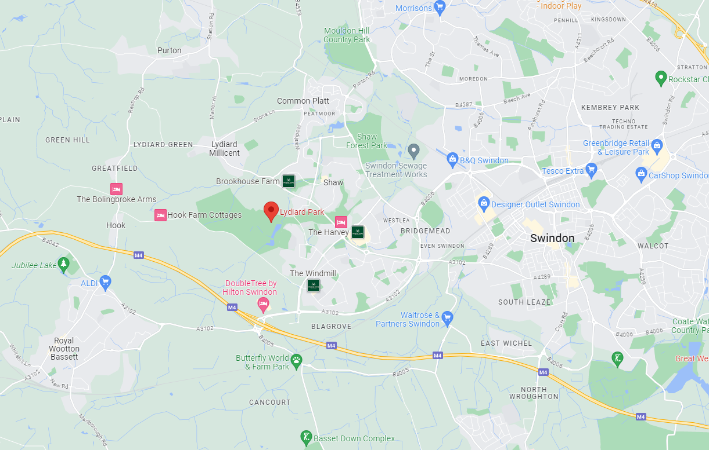

**Refreshments**   
Potato Crazy will be on site over the whole weekend providing a range of food and drinks.

.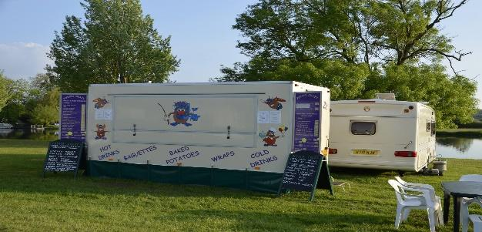

**Entertainment**  
We will be hosting a quiz night on the Saturday evening and would really like as many teams to join us as possible….***Points will make Prizes.***

**UKA Agility Show**  
We would like to make you aware that there will be a UKA Agility Competition taking place over this weekend. Indeed, we have only been able to source this location at the invitation of this shows organiser.

We would therefore ask that all Flyballers attending the competition are mindful of this and abide by both UKA, Odyssey and Lydiard Park signage and rules throughout the weekend. By doing so we very much hope that all competitors, both Flyball and Agility, can gain a genuine appreciation for each other's sports and experience a great event and ultimately enable us to be able to host at this venue in the future.

**We look forward to seeing you all in September.**

**Odyssey Flyball Club**

**Tournament Rules and Regulations**

**Requests for specific days.**We will try to accommodate requests for specific days from teams, however this cannot be guaranteed. It is difficult to consider any requests until the running orders have been completed, 2 weeks prior to the event. Sadly, refunds will not be issued if we are unable to accommodate your request and you withdraw beyond the competition closing date.

(1) The Event Organizer(s) reserve the right to refuse entries and admission to the event of any persons not in good standing within the BFA.

(2) No person shall carry out punitive or harsh handling of a dog at the event.

(3) Bitches in season are not allowed near the show area. Mating of dogs is not allowed.

(4) A dog must be withdrawn from competition if it is:

(a) Suffering from infectious or contagious diseases.

(b) A danger to the safety of any person or animal.

(c) Likely to cause suffering to the dog if it continues to compete.

(5) It is the Teams Captain’s responsibility to ensure the team is available for their division and running order.

(6) The organizer(s) reserve the right to make any alterations they deem necessary in the event of unforeseen circumstances.

(7) All dogs enter the event at their own risk and whilst every care will be taken, the Event Organizer(s) cannot accept responsibility for damage, injury, or loss however caused to dogs, persons or property whilst at the event.

(8) All owners/handlers must clear up after their dogs. Anyone failing to do so will be asked to leave the venue.

(9) Current BFA Rules and Policies will apply throughout the Sanctioned Tournament

(10) If circumstances make it necessary to cancel the tournament, the organisers reserve the right to defray expenses incurred

**Please be aware of the following rules that apply to this venue;**

**Lydiard Park is a massive site (260-acres), so please make sure you keep an eye on any children you are responsible for, ensuring that they are always supervised by an adult.**

**All signs and health and safety information must be adhered to.**

**All competitors MUST obey any “out of bounds” or restricted areas that are in place.**

**No ground level BBQs are allowed.**

**All vehicles should keep to 5mph on the venue.**

**Please keep driving during the tournament to a minimum.**

**Please ensure generators are switched off between 11pm and 7am.**

**IT IS THE TEAM CAPTAINS RESPONSIBILITY TO ENSURE ALL MEMBERS OF THEIR TEAMS ARE AWARE OF THE RULES AND REGULATIONS FOR THIS SANCTIONED TOURNAMENT**.