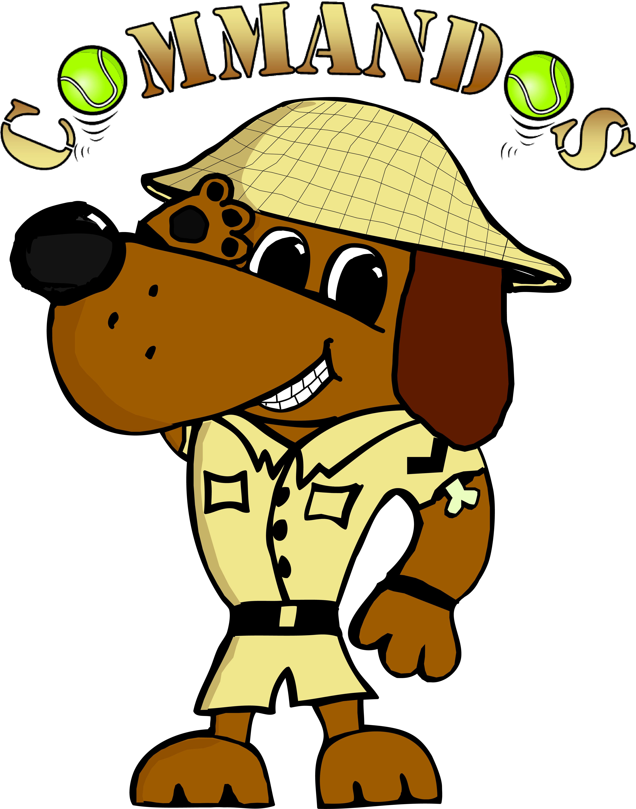


Flyball Teams
Present
Toot Fest
BRITISH FLYBALL ASSOCIATION
Sanctioned Limited
Open Tournament
(48 Teams, one division of starters)
to be held on 8th and 9th September 2018
at
Croft Club
6 Hurworth Place
Darlington
DL2 2DA

Closing date for entries:
21st August 2018
Event is block format held outdoors on grass over the full weekend

Entries via google forms Online Entry form or can be sent to
Tournament Organiser
Jackie Bradburn
Deepdale
Carlton Village
Stockton -on-Tees
TS21 1EA
Tel: 0777 5741407 e-mail commandosflyballteams@gmail.com

Payment either by cheque with entry or by bank transfer before closing date.
Cheques Payable to Commandos Flyball Teams.
Sort Code: 30-98-13
Account Number: 29698968

Limited Open Sanctioned Tournament (48)
Declared times must be submitted in writing (or email) at least 14 days before the tournament & must be at least ½ faster or ½ second slower than seed time. (BFA Rule 4.4)
N.B. Team break-out time is half a second faster than declared time. (BFA Rule 5.17(l))

Teams and dogs must be able to run either Saturday or Sunday
 | Team Name | BFA Number
1
2
3
4
5

Starter Teams – Starters maybe run on either Saturday or Sunday..
 | Team Name | Approx time.
1
2

Team Captain: | Address:
Tel No
Email:

Please name any members wanting to Judge and if QJ, HJ,

 | Camping Details
 | Fri Night Camping @ £7 per night …… units | £
 | Sat Night Camping @ £7 per night ……… units | £
 | Team entries
 | Open Teams ……… @ £40 per team | £
 | Starter Teams ……… @ £25 per team | £
 | Total to pay | £

Please note that we are limited to 70 camping pitches so alternative camping arrangements may be necessary, the TO will contact teams relating to this before the closing date. If camping required for any other nights please contact tournament organiser.
Croft Club serves great value drinks, please try to support the club whilst competing, they however do not serve food, there are local shops, takeaways and pubs that do meals etc.
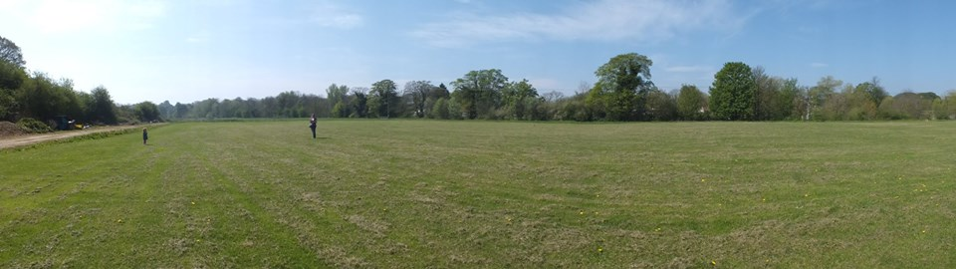

Tournament Rules and Regulations
1) The event organiser(s) reserve the right to refuse entries and admission to the event of any persons not in good standing within the BFA.

2) No person shall carry out punitive or harsh handling of a dog at the event.

3) Bitches in season are not allowed near the tournament area. Mating of dogs
is not allowed.

4) A dog must be withdrawn from competition if it is:
a) Suffering from infectious or contagious diseases.
b) A danger to the safety of any person or animal.
c) Likely to cause suffering to the dog if it continues to compete.

5) It is the Team Captain’s responsibility to ensure the Team is available for their
division and recording of running order.

6) The organiser(s) reserve the right to make any alterations they deem
necessary in the event of unforeseen circumstances.

7) All dogs enter the event at their own risk and whilst every care will be taken,
the Event Organiser (s) cannot accept responsibility for damage, injury or loss
however caused to dogs, persons or property whilst at the event.

8) All owners/handlers must clear up after their dogs and deposit waste in
designated areas provided on site, to enable us to keep this venue for any
further competitions. Anyone failing to do so will be asked to leave the venue.

9) If circumstances make it necessary to cancel the tournament, the organisers reserve the right to defray expenses incurred by deducting such expenses from the entry fees received

10) BFA Rules and Policies operative at the closing date for entries will apply
throughout the Sanctioned Tournament.

