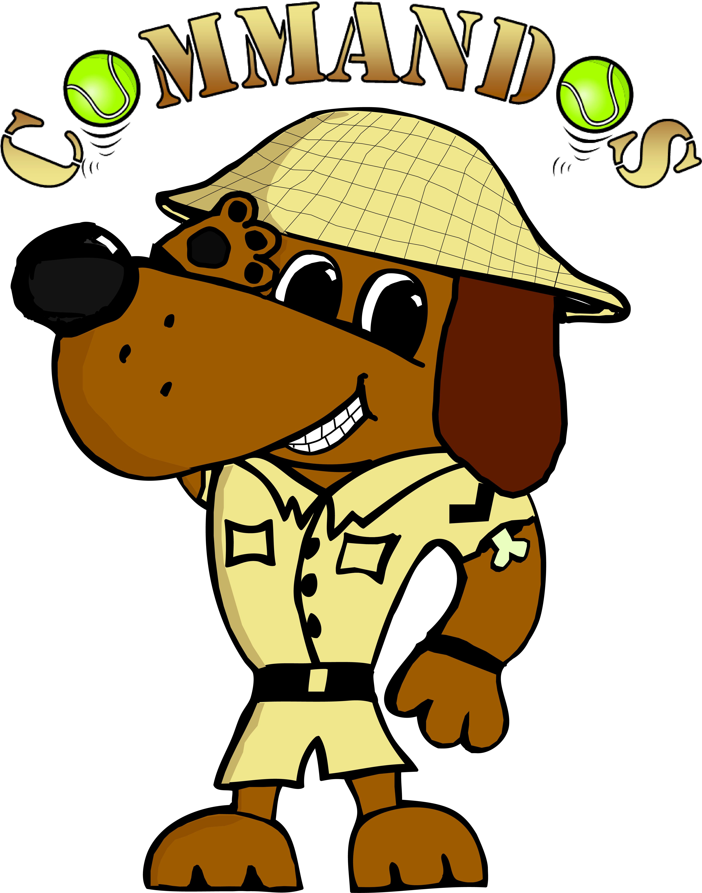


Flyball Teams
Present
Summer Toot Fest
BRITISH FLYBALL ASSOCIATION
Sanctioned Limited
Open Tournament
(48 Teams, one division of starters)
to be held on
17th and 18th June 2017
at
Croft Club
6 Hurworth Place
Darlington
DL2 2DA

Closing date for entries:
18th May 2017

Event is held outdoors on grass over the full weekend

Entries via Iball4flyball or can be sent to
Tournament Organiser
Jo Johnson
Valley View
Houghton Le Side
Darlington
DL2 2XH
Tel: 07803 938360 e-mail commandosflyballteams@gmail.com

Payment either by cheque with entry or by bank transfer before closing date.
Cheques Payable to Commandos Flyball Teams.
Sort Code: 30-98-13
Account Number: 29698968
Limited Open Sanctioned Tournament (54)
Declared times must be submitted in writing (or email) at least 14 days before the tournament & must be at least one second slower than seed time. (BFA Rule 4.5)
N.B. Team break-out time is half a second faster than declared time. (BFA Rule 5.17(l))

Teams and dogs must be able to run either Saturday or Sunday

 | Team Name | BFA Number
1
2
3
4
5
6

Starter Teams – Starters will be run on the Sunday.
 | Team Name | Approx time.
1
2

Team Captain: | Address:
Tel No
Email:

Please name any members wanting to Judge and if QJ, HJ,

 | Camping Details
 | Fri Night Camping @ £7 per night …… units | £
 | Sat Night Camping @ £7 per night ……… units | £
 | Team entries
 | Open Teams ……… @ £40 per team | £
 | Starter Teams ……… @ £25 per team | £
 | Total to pay | £

If camping required for any other nights please contact tournament organiser.

Croft Club serves great value drinks, please try to support the club whilst competing, they however do not serve food, there are local shops, takeaways and pubs that do meals etc.
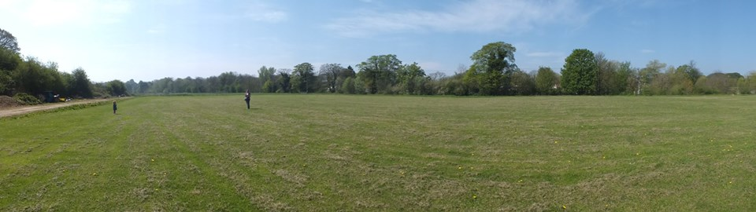

Tournament Rules and Regulations

1) The event organiser(s) reserve the right to refuse entries and admission to the event of any persons not in good standing within the BFA.

2) No person shall carry out punitive or harsh handling of a dog at the event.

3) Bitches in season are not allowed near the tournament area. Mating of dogs
is not allowed.

4) A dog must be withdrawn from competition if it is:
a) Suffering from infectious or contagious diseases.
b) A danger to the safety of any person or animal.
c) Likely to cause suffering to the dog if it continues to compete.

5) It is the Team Captain’s responsibility to ensure the Team is available for their
division and recording of running order.

6) The organiser(s) reserve the right to make any alterations they deem
necessary in the event of unforeseen circumstances.

7) All dogs enter the event at their own risk and whilst every care will be taken,
the Event Organiser (s) cannot accept responsibility for damage, injury or loss
however caused to dogs, persons or property whilst at the event.

8) All owners/handlers must clear up after their dogs and deposit waste in
designated areas provided on site, to enable us to keep this venue for any
further competitions. Anyone failing to do so will be asked to leave the venue.

9) If circumstances make it necessary to cancel the tournament, the organisers reserve the right to defray expenses incurred by deducting such expenses from the entry fees received

10) BFA Rules and Policies operative at the closing date for entries will apply
throughout the Sanctioned Tournament.
Tournament Sponsers.




Jonathan Horsman – designer crates and vet bed.


Tournament Photography – Stuart Laverick will be there all weekend.

