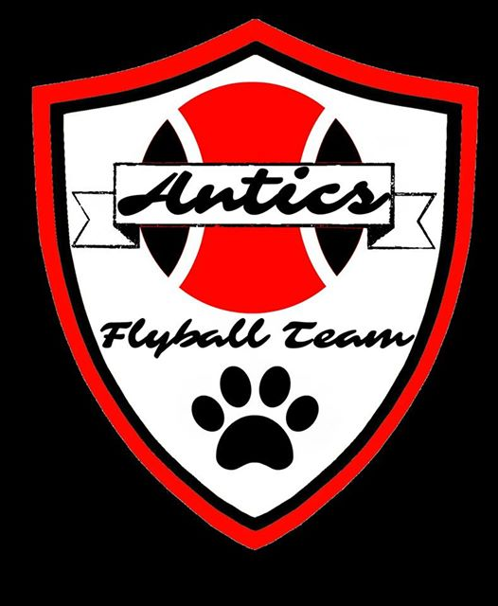 ANTICS FLYBALL TEAM
PRESENTS
BFA SANCTIONED OPEN TOURNAMENTS
AND
STARTERS COMPETITIONS
AT
DOGS UNLEASHED, BAKEWELL SHOWGROUND
23rd and 24th JUNE 2018
(CLOSING DATE FOR ENTRIES – 25TH May 2018)

MAXIMUM OF 24 OPEN TEAMS IN TOTAL EACH DAY
Plus 1 division of starters
(Teams may enter either day but not both)

ROUND ROBIN FORMAT WILL BE USED
RACING WILL FOLLOW BFA RULES AND REGULATIONS

LIMITED CAMPING AVAILABLE – Fri/Sat/Sun

FURTHER INFORMATION AND ENTRIES TO
(no entry will be accepted without correct payment)

Paula Merryman
15 Ravensdale Road
Dronfield Woodhouse
Dronfield
DERBYSHIRE
S18 8QP

anticsflyballteam@talktalk.net

ANTICS FLYBALL TEAM
ENTRY FORM

Saturday 23rd June 2018 (happy to run Sunday if Saturday full? – yes/no)
OpenTeam Name | Declared Times
1
2
3
4
5
6
Starter Team Name | Approximate seed time
1
2
Available judges -

Sunday 24th June 2018 (happy to run Saturday if Sunday full? – yes/no)

OpenTeam Name | Declared times
1
2
3
4
5
6
Starter Team Name | Approximate seed time
1
2
Available judges -

Finance

Amount
…….. open teams @ £40 per team (cheques payable to Antics Flyball Team)
…….. starter teams @ £30 per team
Weekend Camping - £20 per unit (strictly limited numbers)
Total
Show passes required –
1 per person attending required (to a max of 8 per entered team)
Stamped address envelope required to receive show passes. Running orders will be emailed.
Address
Email address
Telephone

Show Rules and Regulations
1. The tournament organiser(s) reserve the right to refuse entries and admission to any person
not in good standing with the B.F.A.
2. No person shall carry out punitive or harsh handling of a dog at the tournament.
3. It is the Team Captains responsibility to ensure the Team is available for its class and
running order.
4. The organiser(s) reserve the right to make any alterations they deem necessary in the event
of unforeseen circumstances.
5. Bitches in season are not allowed near the show area. Mating of dogs is not allowed.
6. A dog must be withdrawn from competition if it is:
a. Suffering from any infectious or contagious disease
b. A danger to safety of any person or animal
c. Likely to cause suffering to the dog if it continues to compete
7. All dogs enter into the tournament at their own risk and whilst every care will be taken, the
organiser(s) cannot accept responsibility for damage, injury or loss however caused to dogs,
persons or property whilst at the event.
8. All owners/handlers must clean up after their dogs.
Anyone failing to do so will be asked to leave the venue.
9. All children must be under the supervision of their parents or carers at all times.
10. No alcohol is to be consumed within or around the ring.
11. If circumstances make it necessary that the tournament is cancelled, the organisers
reserve the right to defray expenses incurred by deducting such expenses from entry fees received
12. A charge of £25 will be imposed on any dishonoured cheques.

