
We are pleased to announce the
Second show of the:

On December 3rd
Tails We Winter Series!
Hosted at
The Lord Roberts Centre, Bisley Camp, Queens Rd, Brookwood, Woking GU24 0NP
On Tuffspun matting with staggered format.

Entries posted to Miss H E Welch, 61 Longfield Avenue, Hackbridge, Wallington, SM6 7AZ or Via Iball

There are three available trophies to collect over the series so even if you miss one you can still be in the running to take home a trophy for the year!
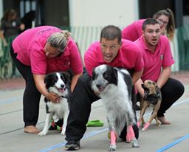
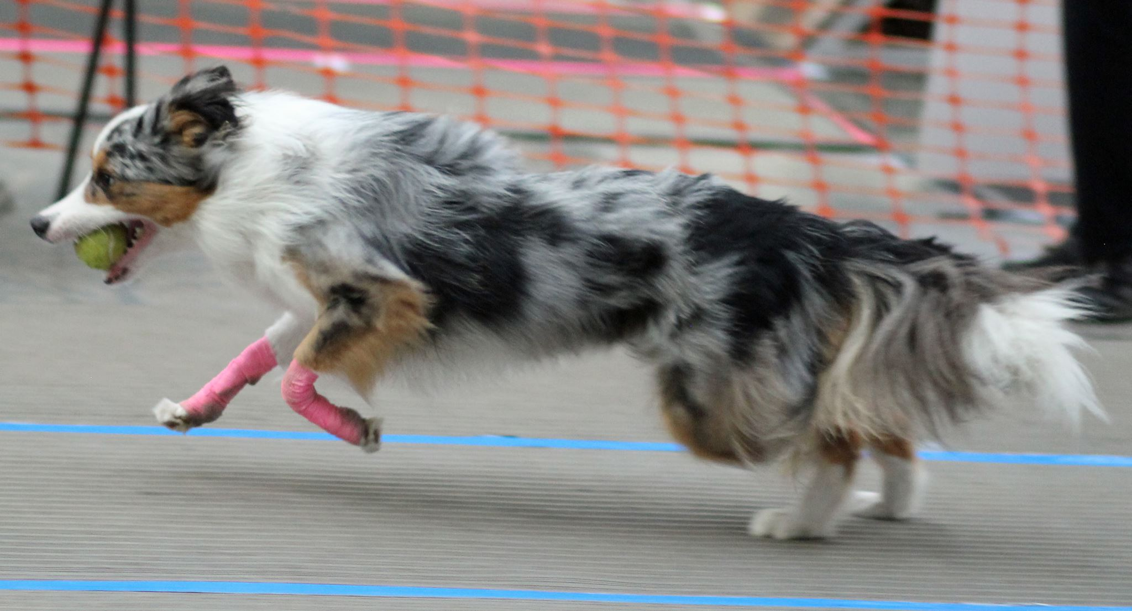
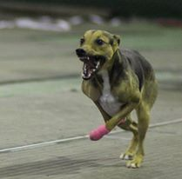

Team Name | BFA number

Team Captain: | Address
Tel:
Email

Number of teams | Price | Total
 | £45.00

1. The tournament organiser(s) reserve the right to refuse entries and admission to any person not in good standing with the B.F.A.
2. No person shall carry out punitive or harsh handling of a dog at the tournament.
3. It is the Team Captains responsibility to ensure the Team is available for its class and running order.
4. The organiser(s) reserve the right to make any alterations they deem necessary in the event of unforeseen circumstances.
5. Bitches in season are not allowed near the show area. Mating of dogs is not allowed. 6. A dog must be withdrawn from competition if it is: a. Suffering from any infectious or contagious disease b. A danger to safety of any person or animal c. Likely to cause suffering to the dog if it continues to compete
7. All dogs enter into the tournament at their own risk and whilst every care will be taken, the organiser(s) cannot accept responsibility for damage, injury or loss however caused to dogs, persons or property whilst at the event.
8. All owners/handlers must clean up after their dogs. Anyone failing to do so will be asked to leave the venue.
9. BFA rules and policies will apply throughout the sanctioned tournament.
10.No alcohol is to be consumed within or around the ring.
11.If circumstances make it necessary that the tournament is cancelled, the organisers reserve the right to defray expenses incurred by deducting such expenses from entry fees received


